August 2026
OADBY HILL WALKING CLUB NEWSLETTER
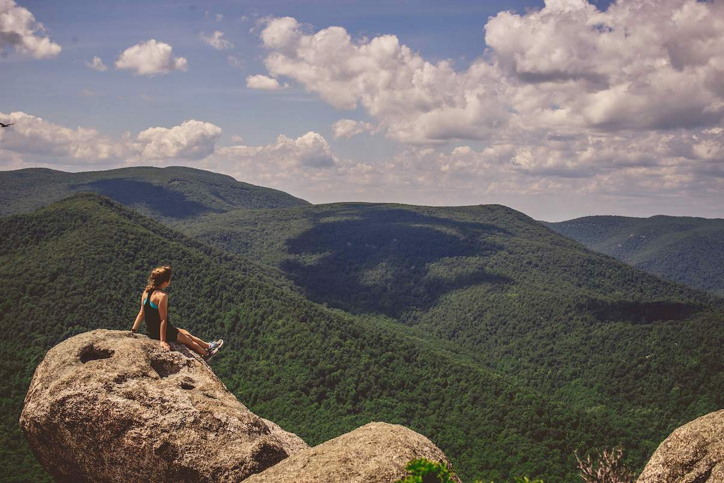
v
Contents
Club Announcements 2
Walking Routes 2
Walking Boots 2
2026/2027 Monthly Walk Destinations 2
OHWC New WhatsApp Community 2
Safeguarding 3
Charitable Endeavours 3
Mcmillan Cancer Support’s Mightly Hike 3
Market Harborough Park Run 4
Cycling from Warsaw to Leicester 5
Lake District Trip – May 2027 5
Derwentwater Hotel, Lake District (1st / 5th May) 5
Last Call for the Dolomites Trip – June 2027 6
Arabba or Selva (24th June / 2nd July) 6
WALKS 7
July’s Monthly Walk Report: Dursley - Gloucestershire 7
August’s Mid-Month Local Walk: Kibworth 9
September’s Monthly Walk: Longnor - Staffordshire (Peak District) 10
Coach Departs 10
Walk Leaders: 10
Pub 10
Map 10
Booking Trips 10
Coach Fare 10
Cancellations - Members & Guests 10
Prospective Walkers 10
Walk Route Map 11
Boot/Toilet Stop 11
Essential Wear 11
Looking for Walk Leaders 11
Summer Walking Tips 12
5 ways to stay safe in the heat 12
Cotswold Outdoors Discount Card for Club Members 13
OHWC discount 13
Cotswold Outdoors Discount Card 14
Meetings 15
Club Media & Bank Details 16
OHWC Committee 2026– 2027 16

Club Announcements

Walking Routes
Can all club members look at the walking routes available on the OHWC website: https://www.oadbyhillwalkingclub.com, & also on the club WhatsApp group prior to joining each month’s coach trip, so the walk list can be passed round the coach more efficiently please. Each month’s walk routes are put up on the club website in the week before the monthly walk.

Walking Boots
Club members are reminded that when joining club walks, they must wear walking boots with ankle support. The only exception to this rule is if club members have a valid medical reason for not wearing boots with ankle support.

2026/2027 Monthly Walk Destinations
Adam Wakley has published the monthly OHWC walk destinations from October 2026 to April 2027. See below:
- 04 October 2026 Langsett, Yorkshire
- 01 November 2026 Long Shawlodge, Peak District
- 06 December 2026 Biggin, Derbyshire Peak District
- 03 January 2027 Wirksworth, Derbyshire
- 07 February 2027 Kingsley Holt, Leek
- 07 March 2027 Taddington, Derbyshire Peak District
- 04 April 2027 Andoversford, Cotswolds

OHWC New WhatsApp Community
By now all of you who were on the original club’s WhatsApp group chat may have realised that you have been tele-transported (Star Trek style!) to the Oadby Hillwalking Club Community. Any group chat related to OHWC is under this community now. Join us, if you haven’t yet!
This is how it works. Our OHWC Community is comprised of several groups:
- Announcements: Only admins can post here. Members can like the posts or reply to them, but cannot post. This is where all the important information will be kept, all in a nice standalone space, so people don’t have to scroll up & down to find the important bits (i.e., walks maps, routes, dates, events, etc).
- OHWC Chat: This is the chat you always had. We are trying to streamline it, with your help, to a chat ONLY about OHWC related matters (i.e., pics from OHWC walks)
- OHWC Lakes 2027: This chat is for the people who have joined for next year’s Lake District Walking Holiday, or would still like to join us.
- General: This group came for free when I created the community. I am trying to make this a space where we can all talk about anything &everything we enjoy without taking over the main OHWC Chat group - we can post pics & chat about our own trips, hikes, hobbies- share interesting articles or videos, petitions, etc. I have noticed that people have already started to use it this way. It would be great if more people from the community join. We have 13 members. PLEASE aim to use this group for all non-OHWC related posts.
Once you join the community, you can choose what group chat you want to join, stay on or leave. You can request to join groups if you automatically are not added, & if you don’t want to participate in the chats, then you can just stay only with the announcements.
I welcome all of your feedback & ideas to improve our WhatsApp community. Let’s make it great!

Safeguarding
The OHWC is committed to safeguarding in line with national legislation,& national & local guidelines. We ensure safeguarding by ensuring our club is run in a way which keeps our club members safe.
We all have a responsibility to safeguard adults & young people who are experiencing, or are at risk of, abuse & neglect.
The OHWC is committed to creating a culture of zero tolerance of harm to our club members which necessitates:
- The recognition of club members who may be at risk & the circumstances which may increase risk.
- Knowing how abuse, exploitation or neglect manifests itself.
- And being willing to report safeguarding concerns.
The OHWC Safeguarding Policy & associated procedures apply to all individuals who are involved in the OHWC, including the committee & the walk leaders, to all concerns about the safety of club members whilst taking part in club activities,& in the wider community.
All club members are encouraged to report any safeguarding concerns, no matter how trivial they seem to the club at OHWCsafeguarding@gmail.com.All such communications will be treated as strictly in-confidence& will be investigated thoroughly.
The OHWC Safeguarding Policy & Guidance document is on the club website at https://www.oadbyhillwalkingclub.com/safeguarding.html

Charitable Endeavours

Mcmillan Cancer Support’s Mightly Hike
By Tim Akers
Tim, Elaine Akers, & Clare Savage completed their26 Mile Mighty Hike around the Gower Peninsula for Macmillan Cancer Support (27th June 2026)
On the evening of the 27th June, after 12 hours & a few minutes of walking, we crossed the finish line of the 2026 Gower Peninsula Macmillan Cancer Research Mighty Hike. 26 miles smashed!! Thank you to all those who sponsored us today & the last few weeks. Your very generous donation means that £531 is winging its way into Macmillan Cancer Research coffers.
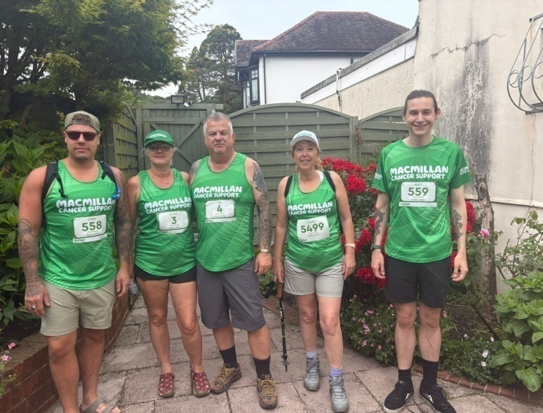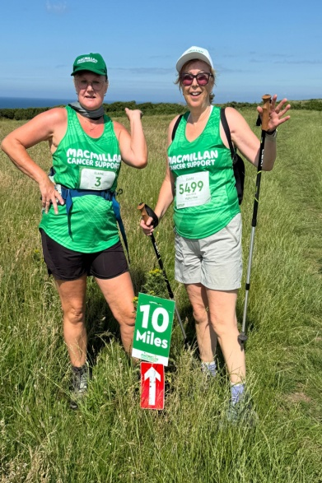

Just because we’ve finished the mighty hike doesn’t mean that sponsorship stops. My justgiving page remains live for another 4 weeks or so; so please pleaseplease give generously to this wonderful cause!
Tim’s JustGiving page is here:Tim Akers's Gower MacMillan Fundraising page
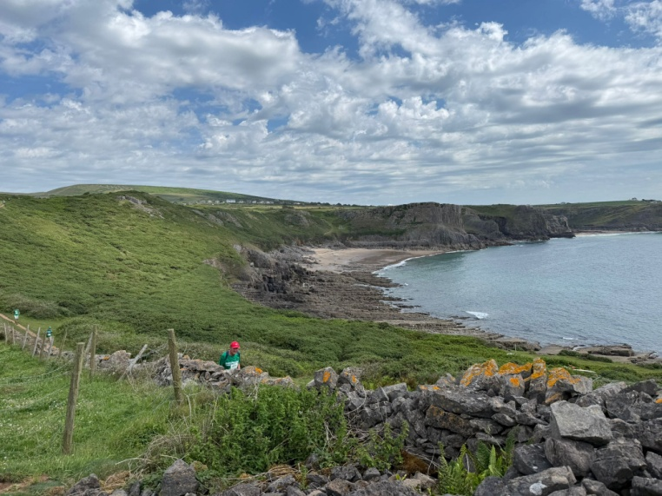
*Elaine, Tim & Clare are hugely grateful for any sponsorship received from Club members*

Market Harborough Park Run
By Kevin Millard
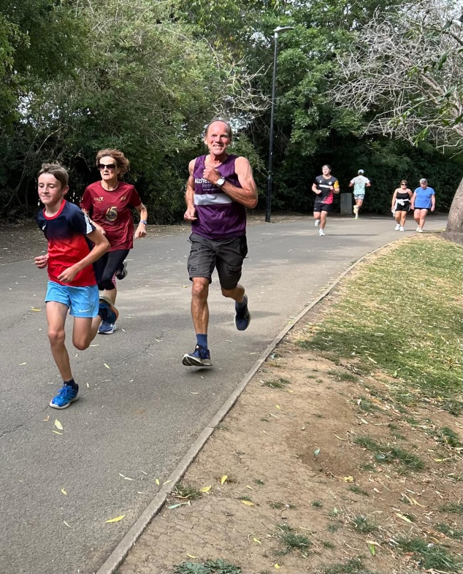 | If you go down to Market Harborough’s lovely Welland Park on a Saturday morning, watch out for Kev Millard & 400 other Parkrunners & walkers all trying to look like they are enjoying the experience while being cheered on by the 30+ volunteers who make sure everyone stays safe. A great start to the weekend. With nearly 1000 locations around the UK, there’s a Parkrun near You!  Market Harborough ParkRun  ParkRunUk  

Cycling from Warsaw to Leicester
By Shirley Thomas
I’m cycling Warsaw to Leicester to honour my sister who died in April of Pancreatic cancer. Hopefully crossing into Germany tomorrow. Poland has been great.  I’m with 3 friends & we’re following the Eurovelo2 - Capitals route. The Polish section isn’t very developed and we’ve travelled some pretty tricky tracks.  Wished I’d had an electric at times today! At the moment we’re averaging 55miles a day, fully loaded.  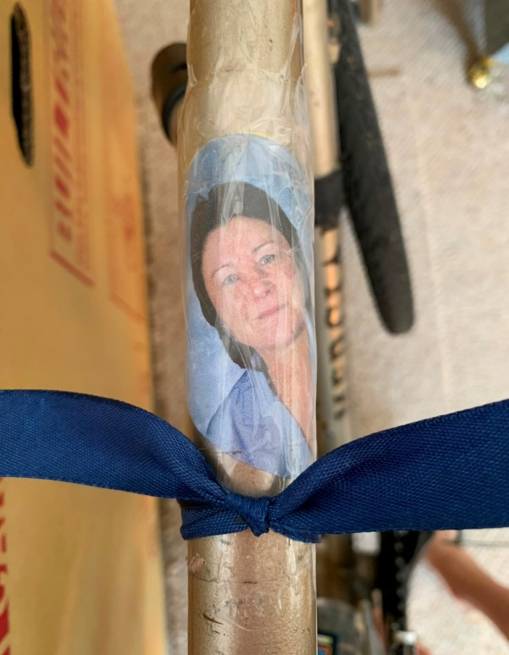 | 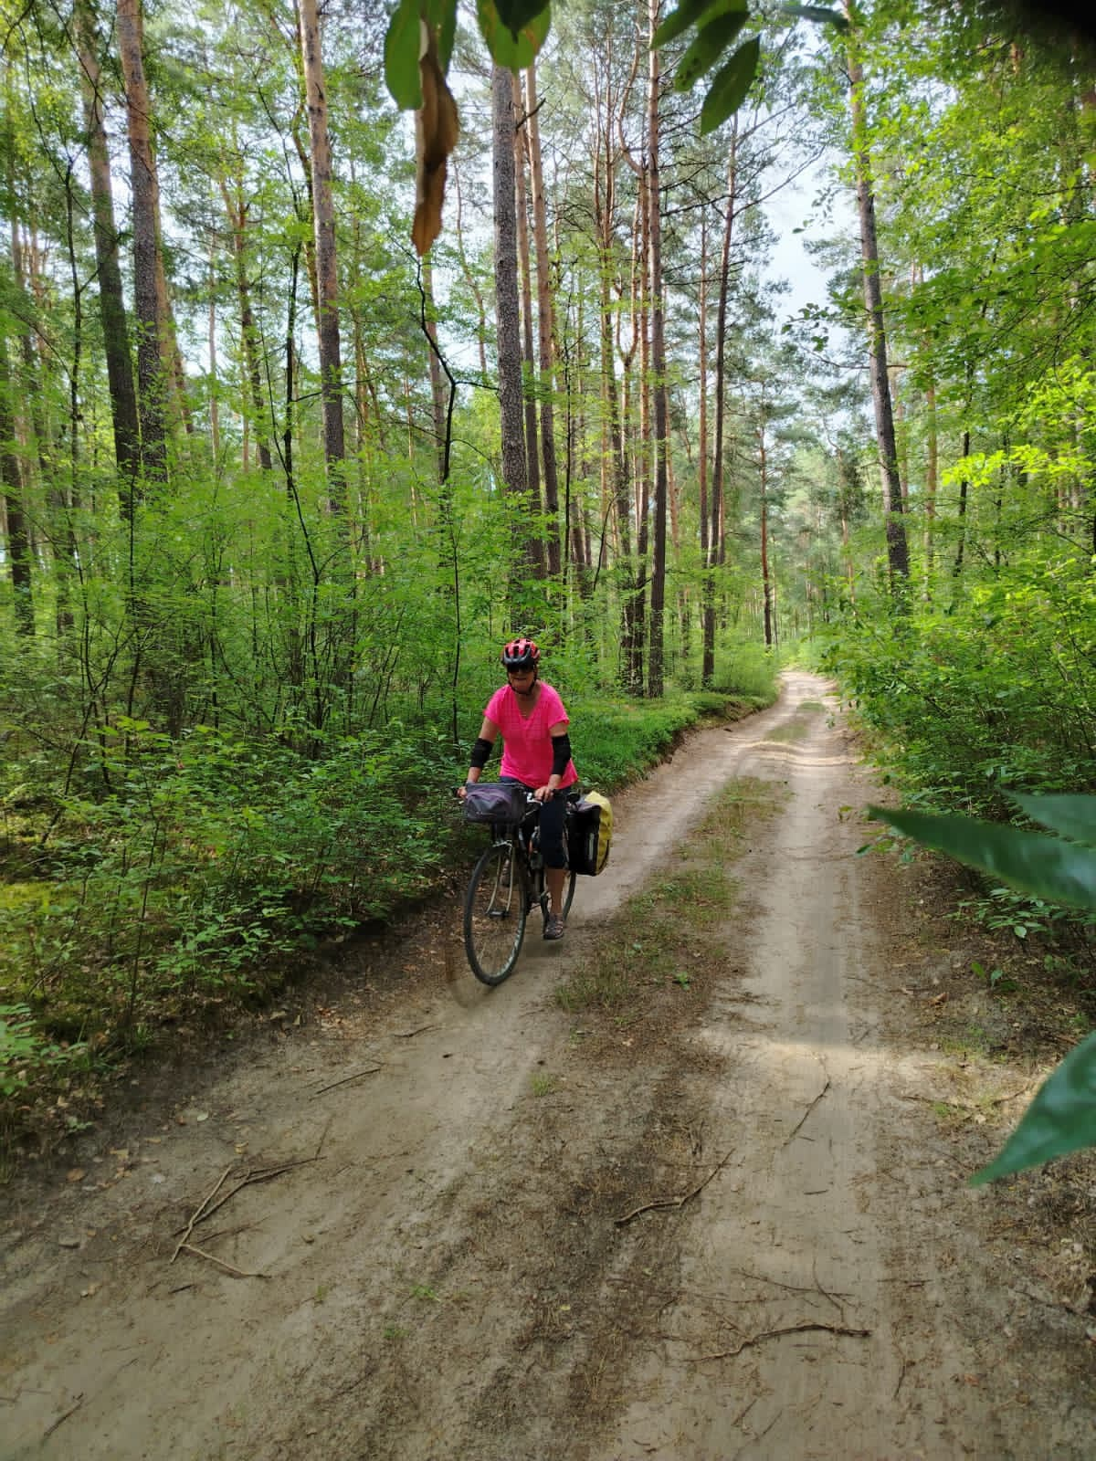

Lake District Trip – May2027

Derwentwater Hotel, Lake District (1st / 5th May)
The committee are pleased to confirm that we've taken the last rooms available in the Patterdale Hotel for our May 2026 trip.
There are now 28 members going to the Derwentwater Hotel in May 2027. There may still be some availability if other club members wish to attend the party. Telephone Alfa Travel on 01257 248000 should you wish to make enquiries.
Don’t forget to join our WhatsApp OHWC Lakes 2027 group for all the latest info about the trip!

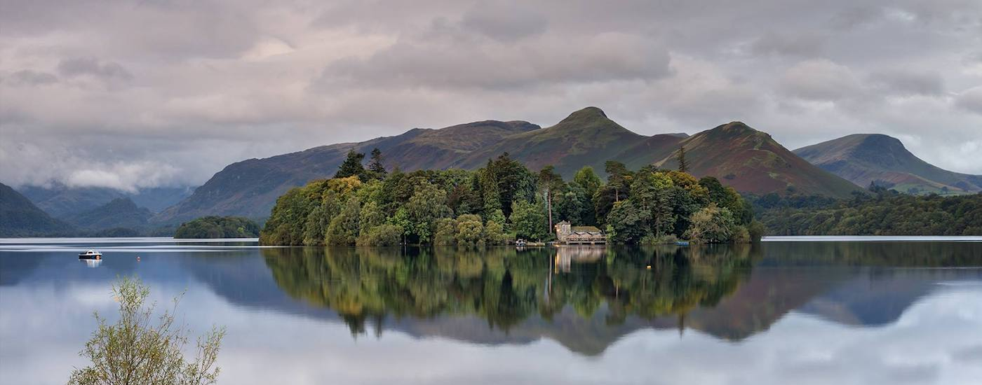

Last Call for the Dolomites Trip – June 2027

Arabba or Selva (24th June / 2nd July)
At July’s club meeting, your committee decided to explore the possibility of another trip to the Dolomite Mountains in Italy. Previously in 2024, Alison & myself organised all matters; finding a hotel in an appropriate resort, booking the pre-flight hotel in the UK, flight research, transport in the UK & Italy, researching & leading most of the walks. Whilst we were mainly repeating walks we had previously completed, we had a lovely time as we were with such a great bunch of people. If there is interest in a trip next year, we want to change things so that there is less reliance on a limited number of people to organise all matters & lead the walks. We are considering the ski resorts of Arabba or Selva which re-open their ski lifts in mid June. Arabba is probably less expensive than Selva in terms of accommodation & lift passes & is therefore first choice. Both offer good mountain walking. The provisional travel dates are Thursday 24th June to Friday July 2nd, giving us 7 days walking. The mid week flights would be less expensive.
Are there club members who would be prepared to form a group to research & organise matters? However, as an alternative, I have already spoken to Millingtons Travel Agents in Market Harborough who are prepared to help. Perhaps this would be the best solution? In any event, we will need people, or ideally groups of people, who are prepared to research walks in advance, & then collectively lead them. This isn’t difficult for club members as all are competent walkers. There are ski lifts, numerous refugios, the walks are well signposted & well worn. The local maps are good & apps like All Trails and Map.me are very good. The internet gives you numerous ready-made downloadable routes through All Trails.
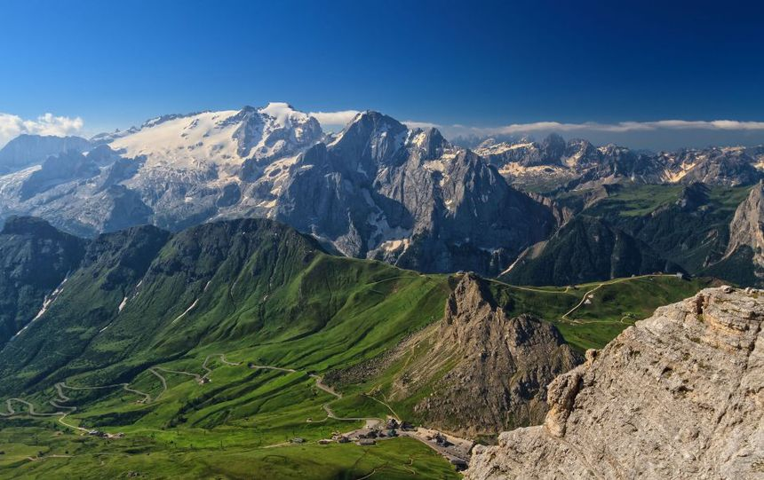

This year, moving forward we will be encouraging more club members to lead routes assisted by the current leadership using maps and/or the OS Maps app on their phone to ease the burden on the club's small group of regular leaders. This will help in Italy.
In terms of cost, I haven’t the faintest idea!! In 2024, I brought the trip in with a total cost of £1200 per person. We’re now living in different times in terms of flight costs. A wild guess would be of the order of £1600 for 9 days.
To make transportation manageable, I think the maximum number should be limited to 15 members – 11 members have signed up so far! If you are interested in going to The Dolomites & recognising that you will be asked to participate actively in making the trip successful, please respond accordingly to mylast emailby the 23rd August.

WALKS

July’s Monthly Walk Report: Dursley - Gloucestershire
By Jo Stapleton
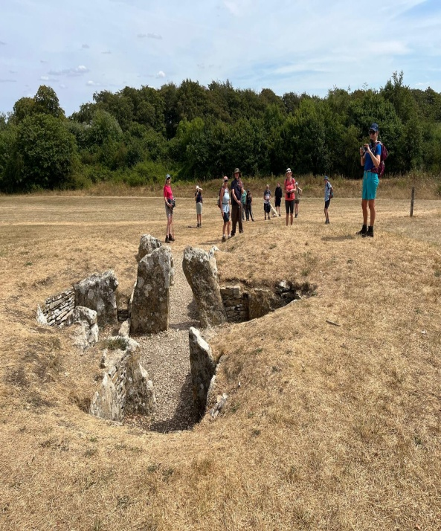
The Cotswolds (Sunday, 2nd August 2026) – Lesley’s Walk (9.5 miles / 500 m elevation)
Our recent walk in the Cotswolds led by Lesley was an enjoyable mix of gentle scenery, history & good company. The route took us through some lovely Gloucestershire countryside, with plenty of opportunities to enjoy the views & shelter from the sun in the quiet woodlands.  One of the historical features was Nympsfield Long Barrow, a Neolithic burial monument dating back around 5,000 years. These long barrows were built by early farming communities as communal burial places, & the Nympsfield monument gives us a reminder of prehistoric times and the history beneath our feet.  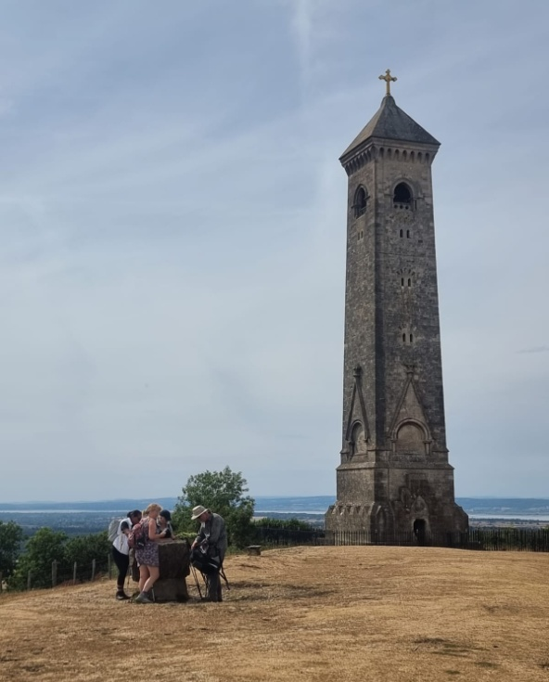  Thank you, Lesley!    Butterflies seen on the Walk!    Common Blue  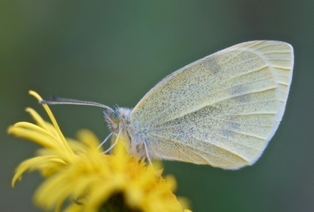  Small White  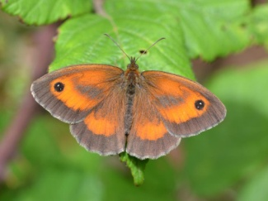Gate Keeper | 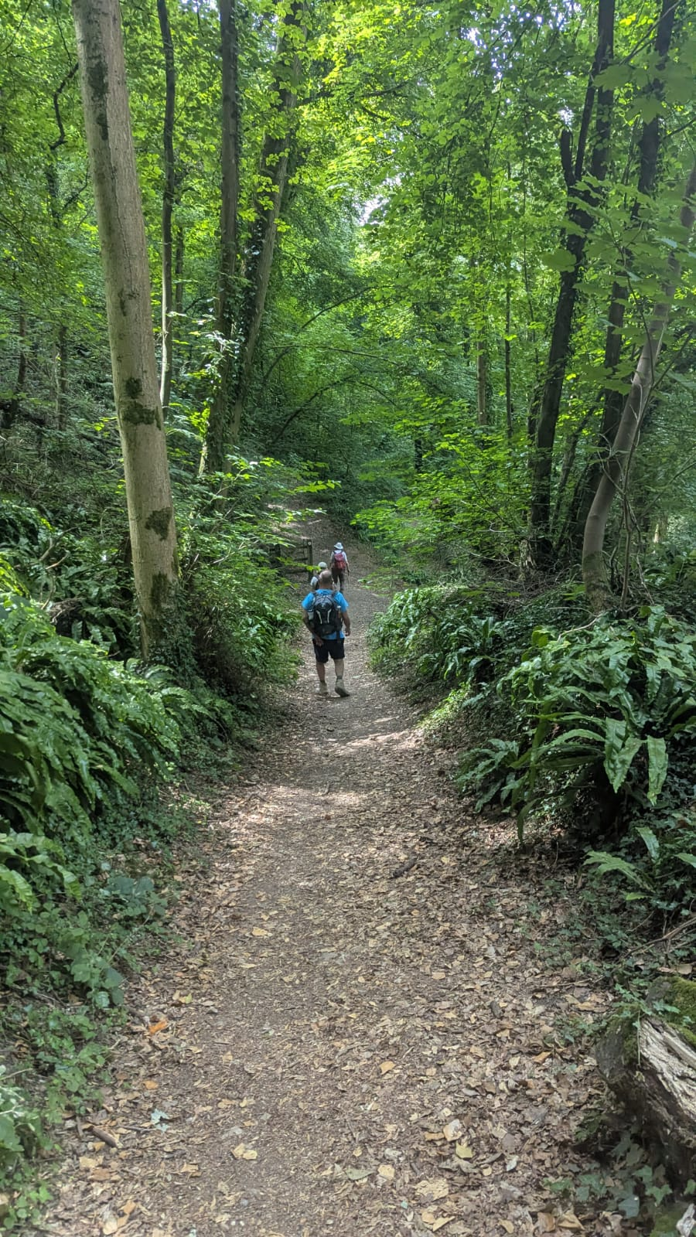  From there, the walk continued through Coaley Park Nature Reserve, an attractive area of woodland and countryside with a variety of habitats & wildlife. The reserve is evidently a place for dog birthday parties, several labradors sported birthday bandannasas they enjoyed their canine party! This was followed by a peaceful and scenic section of the route, with some lovely views across the surrounding landscape. Colin spotted a number of beautiful butterflies.  Despite the heat we all took the opportunity to walk around Uley Long Barrow: Uley Long Barrow (Hetty Pegler's Tump) | English Heritage - also known as Hetty Pegler's Tump. This is another important Neolithic burial chamber, dating from around 5,000 years ago. It is one of the best-preserved prehistoric monuments in the Cotswolds a reminder of the area's rich history.  The combination of rolling countryside, woodland & historic sites made for a varied & interesting walk. There was also plenty of friendly conversation & socialising along the way.  Thank you to Lesley for stepping in to lead the walk & provide history and lovely countryside before we all headed to refreshments at the pub in Dursley! The sign outside the pub read:  “Steep hill up there; refreshing cool beer in here” No contest!  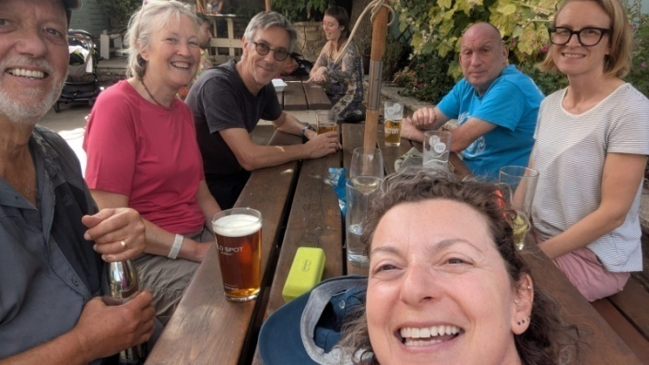  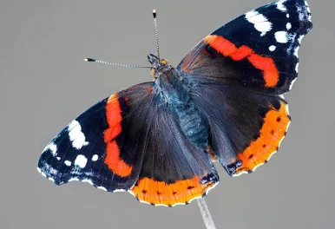  Red Admiral  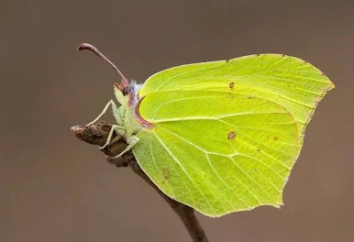  Brimstone   Painted Lady
“I did Karl’s walk, which was 12 miles & only 3 of us, so it gave me the opportunity to test my new walking app Komoot in view of leading a walk sometime this century. Thank you Karl & Ian for your patience! And that hill at the end was an awesome treaaaaat! This is my favourite pic from our walk!”  Gala | 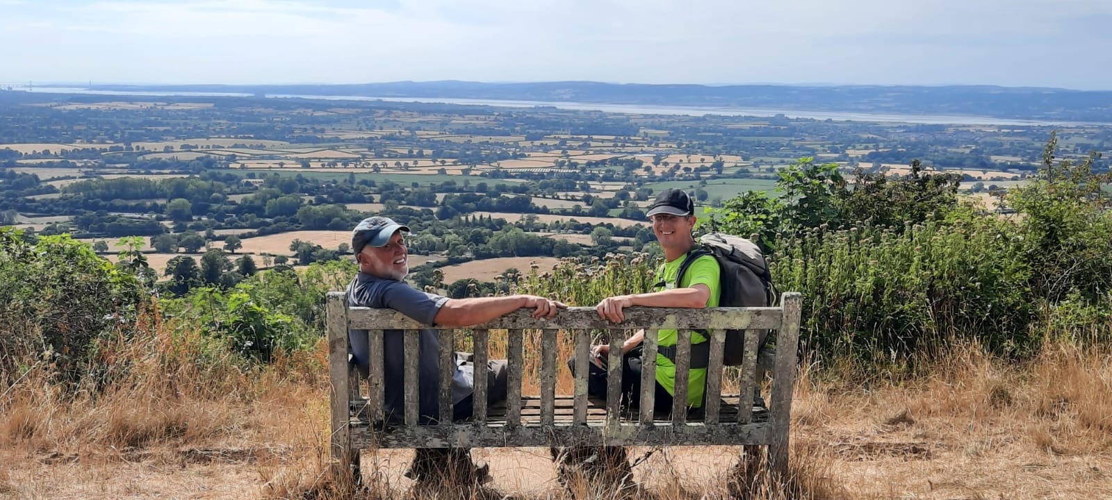

August’s Mid-Month Local Walk: Kibworth
Led by Colin New
*Please Note: this walk has been cancelled due to low numbers – new date TBC*
Sunday 16th August 2026 – Kibworth – 8 miles
Colin has kindly offered to lead August’s Mid-Month Walk. Find all the details below:  Meeting Time: 09:30am (Please, arrive 15 minutes earlier)  Meeting Place: Kibworth Hub, free car Park off School Road Kibworth, LE8 OJE  Public Transport: X3 Bus to Kibworth  Walk Route: A6 / Kibworth Harcourt / Burton Overy/ Great Glen / Oadby / Pass the Golf course to Newton Harcourt / Wistow (toilets & drinks & pack lunch – 15/20 min) Fleckney / Kibworth  Pub: The Swan  Please, let Colin know if you would like to join this walk on 07939 076486 | 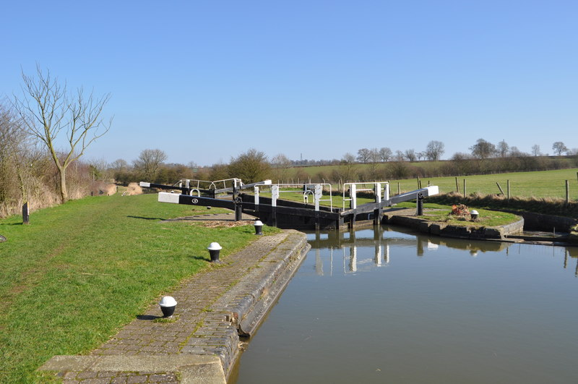

September’s Monthly Walk: Longnor - Staffordshire (Peak District)
Sunday 6th September 2026
Coach Departs: Oadby Central Car Park (adjacent to the Trinity Methodist Church) at 8.00am sharp. | 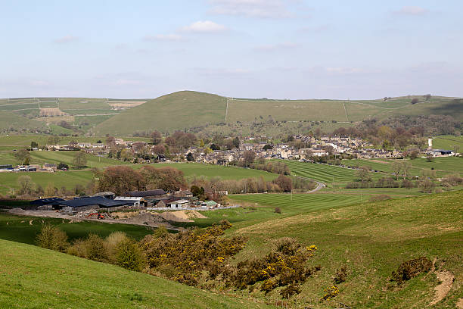  Walk Leaders:  Click on each leader to see theirroute’s OS map  - Kevin Millard (Long-14 miles)  - Karl Pochin(12 miles)  - Adam Wakley (11 miles)  - Robert Davidson (10 miles)  - Helen Everett (Short - 8 miles)

Boot stop: Tibshelf Services
Pub: Ye Old Cheshire Cheese Inn
*Please note:The coach will leave the pub at5.30pm.
Map: OS Explorer OL24: OS Map of Peak District – White Peak Area


Booking Trips
When booking onto monthly & mid-month walks, please only use the club email rather than phone, text or word of mouth. Alternatively, for the monthly walks, put your name down on the list passed on the return monthly bus.
Coach Fare
Preferably by BACS to the bank details given at the end of this Newsletter.
- Adult Members £18
- Guests £20
- Junior/Student Members £12

Cancellations - Members & Guests
- Cancellations up to Tuesday midnight before the Sunday walk - no penalty.
- Cancellations thereafter - the full cost of the bus fare is due.

Prospective Walkers
If you have not put your name down on the list passed on the last coach trip, please contact ohwcmail@gmail.com to book a seat on the bus this month, prior to making a payment. You will receive a reply confirming the availability or otherwise of a seat. Please note that it is first come first served.
If you delay booking, you may not get a seat. Please do not turn up without booking & receiving confirmation that you have a place.
You must book a place on the coach in advance, or you may not be allowed to go on as it picks up members who have already booked a seat at various places on the ring road.
If you wish to be picked upfrom other places than Oadby Car Park, please mention where at time of booking& please be aware that very occasionally another Orbit coach may go past before ours arrives.
Walk Reminder
Essential informationfor all OHWC walks can be found on the OHWC Website here.Please ensure that you carry your completed Club Safety Form in the toppocket of your rucksack - it could help you in a difficult situation. N.B. Don’t forget to keep the form up to date. The form is available on the Club Website here.

Walk Route Map
Please go onto the News section of the Club website here, the Announcements section of our WhatsApp Community or our closed Facebook group,a few days before the monthly walk, to see a map showing the walk routes as well as the individual routes. Hopefully, this will speed up selecting your walk when signing up on the coach.The club has four to six OS maps available for Walk Leaders to use when leading walks.

Boot/Toilet Stop
Members are urged to keep the time taken at the boot stop to a minimum. At the end of the walk members should change their footwear & place dirty boots & rucksacks in the luggage locker before getting onto the coach, thus avoiding any congestion & mud in the coach.
Please do not wear dirty boots on the coach.
Those getting off the coach at Fosse Park & the Ring Road may alternatively put your dirty kit into a plastic bag & then take it onto the coach; thus, negating having to search for your gear in the bus luggage lockers.

Essential Wear
Members& guests must be suitably equipped. As a minimum this must include:

- Suitable waterproof walking boots that have adequate ankle support
- Waterproof coat & over-trousers
- Warm clothing
- An appropriate rucksack.
- Food & drink for the whole day
- For winter walking, all members are to carry a serviceable head torch in their rucksacks.
- A First Aid Kit is recommended

N.B. Jeans& trainers/sandals are NOT suitable. If you are not properly equipped for hillwalking, you may not be able to participate. Only Registered Assistance Dogs are allowed on club walks, except on mid-month walks at the discretion of the Walk Leader.

Looking for Walk Leaders
We are having some issues finding available walk leaders, mainly for our local Mid-Month Walks. We would like to encourage members, who may or may not have ever led before, to give it a go! You will receive training & you will not be on your own, as you will be accompanied by an experience leader during your initial walks. All Trails & OS Maps are good navigating apps for starters. You can download them on your phone & use off road maps for a small yearly subscription fee.

Summer Walking Tips

5 ways to stay safe in the heat
It’s great to go walking on sunny summer days. Read our top tips for staying safe in the heat
How to stay safe and enjoy our summer walks
Who doesn’t love a summer’s walk on a blue-sky day? From the promise of an ice cream to a dip in the sea, there's something for us all to look forward to on a summer walk. More daylight and less layers make such a difference. And with a little bit of planning, we can be sure to enjoy the heat and the sunshine safely.

Here are our five top tips for staying safe in the heat:

1. Check the weather and plan ahead  Check the weather and plan your clothing accordingly. But also plan for weather changes, however unlikely it seems. Pack a light waterproof jacket in case of unexpected showers. It may also come in useful if you’re walking in the hills where it is often much cooler higher up than lower down.  If the forecast is for hot weather plan to walk in the early morning or the evening if possible and avoid walking at the hottest times (11am - 3pm). Take frequent breaks in the shade. If we’re having one of Britain’s rare heatwaves, you may want to consider a shorter walk than usual. Or plan a route with plenty of shade, such as a woodland walk. It’s also worth working out a spot where you can cut your walk short if you need to. | 2. Use sun protection  Make sure to apply plenty of sun cream (SPF 30+) and keep reapplying regularly throughout your walk. Your forehead, scalp and ears are particularly vulnerable areas so wear a hat, even on overcast days. A wide brim and a neck flap will keep the sun off your face, head and neck.  In the heat it is a natural impulse to remove clothing so choose loose, lightweight items that protect your arms and legs but don’t make you overheat. Fabrics with a tight weave offer the best protection. And if you do remove a piece of clothing, you may be exposing skin that has not been sun-protected so remember to apply sun cream to these areas.
3. Hydrate, hydrate, hydrate  Carry plenty of water with you. You’ll definitely need more than in cooler weather. The extra weight will be worth it, and a water bladder is worth considering to make it easy to carry and drink your water. Sip regularly to avoid getting dehydrated. Don’t wait until you feel thirsty.  If you’re heading out on a longer hike, take some water purifiers with you just in case of an emergency. | 4. Look out for your hiking friends & group  Keep an eye on your fellow walkers in the heat. Sun protection isn’t just about sunburn. Look out for signs of heatstroke and heat exhaustion. Melanoma Fund have some great advice about spotting, preventing and treating heat related illness, as part of their Sunguarding Sport guidance.  Don’t forget your four-legged friends. If you’re taking your dog along on your walk, make sure you take some water for them too, and let them have a lie-down in the shade when they’re looking tired.
5. Protect the countryside

The summer heat can create very dry conditions. Help keep the countryside safe by looking out for fire risks. Do not light fires and report unattended fires, or activities which could cause fires to the emergency services. Only have barbeques where signs say you can.

And as with every walk, always follow the Countryside Code in England and Wales, or the Scottish Outdoor Access Code.

Source: Ramblers Website

Cotswold Outdoors Discount Card for Club Members
Once again, Cotswold Outdoors has allowed all Club members to apply for a Discount Card. This discount is for the personal use of club members only & must not be shared with others.
Club members benefit from:
- 15% discount in-store & online,
- Expertise, advice & guidance,
- Sustainability services,
- Explore More membership.

OHWC discount
OHWC Club Members will receive a 15% discount on full-priced items (excludes electronics & selected lines) both in-store & online with Cotswold Outdoor, Runners Need & Snow+Rock. The code to use is AF-RAMBLERS-MBB.
This discount is strictly for personal use only & must not be shared with non-club members. Cotswold Outdoors reserve the right to amend or cancel it with immediate effect if they find this code has been leaked to unauthorised persons in any way.

Explore More
Club members will need to sign up for their free Explore More benefits scheme to use the discount. This comes with its own benefits such as a 3-year warranty, a 100-day returns policy, Price Match Promise & much more! Members can sign up through any of the following brands:
- Cotswold Outdoor
- Runners Need
- Snow+Rock

Expertise, advice & guidance
The best way to tap into their outdoor expertise is for Club Members to book an in-store appointment at Cotswold Outdoor, Runners Need or Snow+Rock. This ensures one of our store specialists is on hand to help you get the best kit for your adventure.
Alternatively, Cotswold Indoor has a whole host of blogs online in our Advice & Inspiration areas. These include kit guides, itinerary ideas, inspirational stories & suggestions on how to be more sustainable. You can find these below:
- Cotswold Outdoor
- Runners Need
- Snow+Rock

Sustainability Services
For us the outdoors is everything, & across our three brands, we do everything we can to look after it for generations to come.
As a company, Cotswold Outdoors are working to become more sustainable, & they want to help their customers do their bit too. The services they offer to help with this are available across all their stores:
- Make The Right Choice
- Care & Proofing
- Recycle My Gear
- Recycle My Run
- Our planet

Cotswold Outdoors Discount Card
This year, Cotswold Outdoor, Runners Need & Snow+Rock have requested that OHWC Club members provide some sort of Club Membership Card to receive their discount. To that end, the club committee has decided to produce a Membership Card for club members to use if they want to take advantage of the discount offered.
I would suggest that members keep a photo of the OHWC membership card & the Ramblers Card together in their phone wallets for use in the stores.

*Please print off this& the next page, & cut out the cards illustrated below*



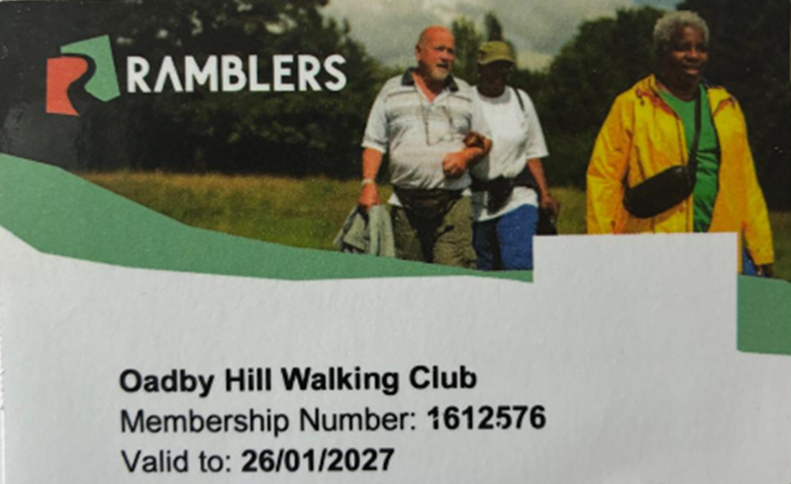

Meetings
Unless otherwise stated in this Newsletter or via email, monthly club meetings are held on the Tuesday following the Sunday coach walk at either the Wigston Conservative Club, 38 Long Street, Wigston, Leicester, LE18 2AH or The Blackbird Pub, Blackbird Road, LE4 0FW at 7.30pm.
Please, note that Septembers’s meeting will take place on Tuesday 1st September at the Blackbird Pub. All OHWC club members are welcome.


Club Media & Bank Details

Website | www.oadbyhillwalkingclub.com
Email | ohwcmail@gmail.com
Safeguarding Email | OHWCsafeguarding@gmail.com
Facebook | Private Group: Oadby Hillwalking Club group  Public Page: OadbyHIllwalking Club
Instagram  WhatsApp | Oadby Hillwalking Club  OHWC WhatsApp Community
Bank Details | Barclays Bank
Account Name | OHWC
Account Number | 50124990  Please quote surname & month of walk  (i.e., Smith July)
Sort code | 20-49-08

OHWC Committee 2026– 2027

Chair | Martin Beckett | 07748 674223
Treasurer | Martin Beckett | 07748 674223
Club Secretary | Ann Branson | 07726 334583
Membership Secretary | Mike Hewitt | 07484 731419
Walks Coordinator | Adam Wakley | 07720 328700
Communication & Social | Gala Suarez | 07810 063353
Safeguarding | Tim Akers | 07855 969183

